Analysis of Legally Operating Business in New York City using Bigdata Technologies

Programming in Data Analytics

Mathiazhagan Sampath

X18139973

**Steps by step procedure involved in analysis of NYC – Legally running business.**

**As JAR file size is more than 100 MB I am not able to upload that.**

**So I had attached the zip folder of eclipse workspace to create Executable JAR file from**

# Login to hduser:

Process flow of the analysis

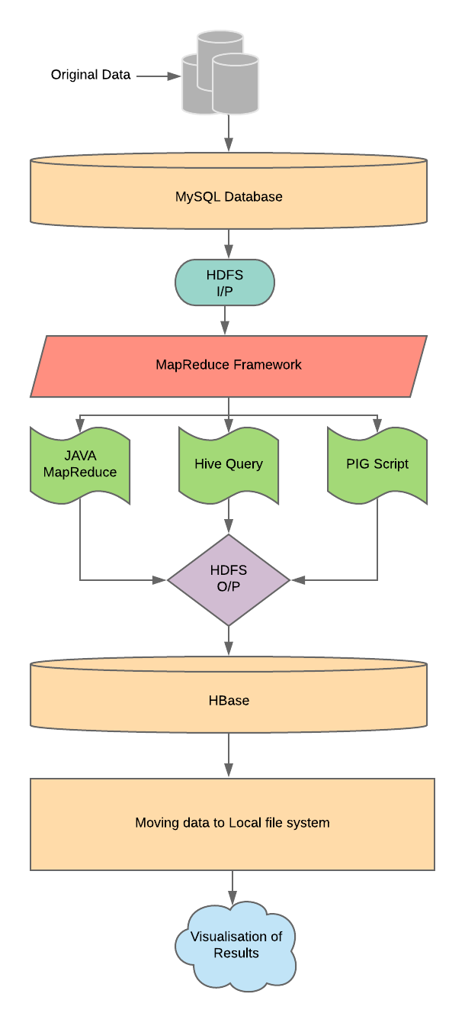

# Login to mysql:

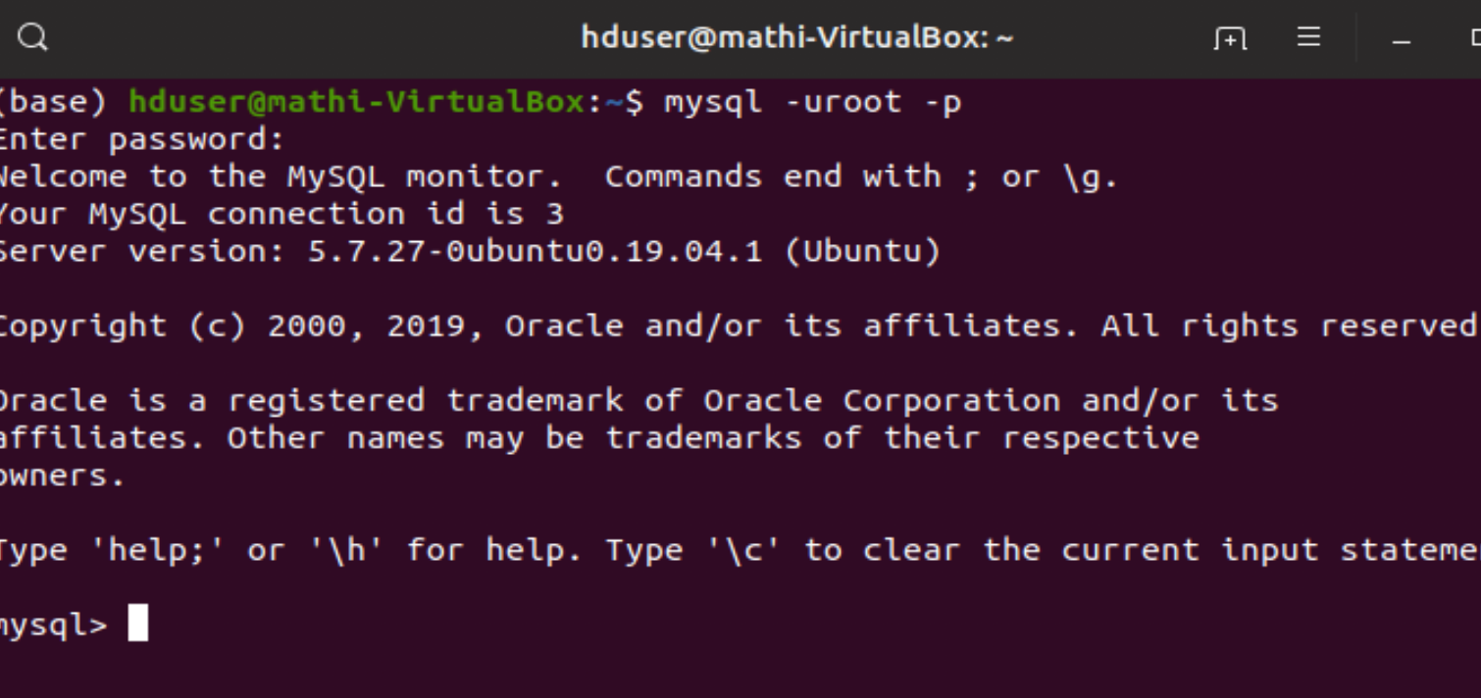

Create table:

CREATE TABLE nycbusiness ( DCANumber varchar(255),LicenseType varchar(255),City varchar(255),Status varchar(255),LicenseCreationDate varchar(255),Industry varchar(255),ExpDate varchar(255),

BusinessName varchar(255),Building varchar(255),

Street varchar(255),AddressCity varchar(255),

State varchar(255),Zip INT,AddressBorough varchar(255),CouncilDistrict INT,Detail varchar(255),Longitude varchar(255),Lattitude varchar(255));

# Load data into sql

load data local infile

'/home/hduser/nycbusiness.csv' into table

nycbusiness fields terminated by ',' lines terminated by '\n';

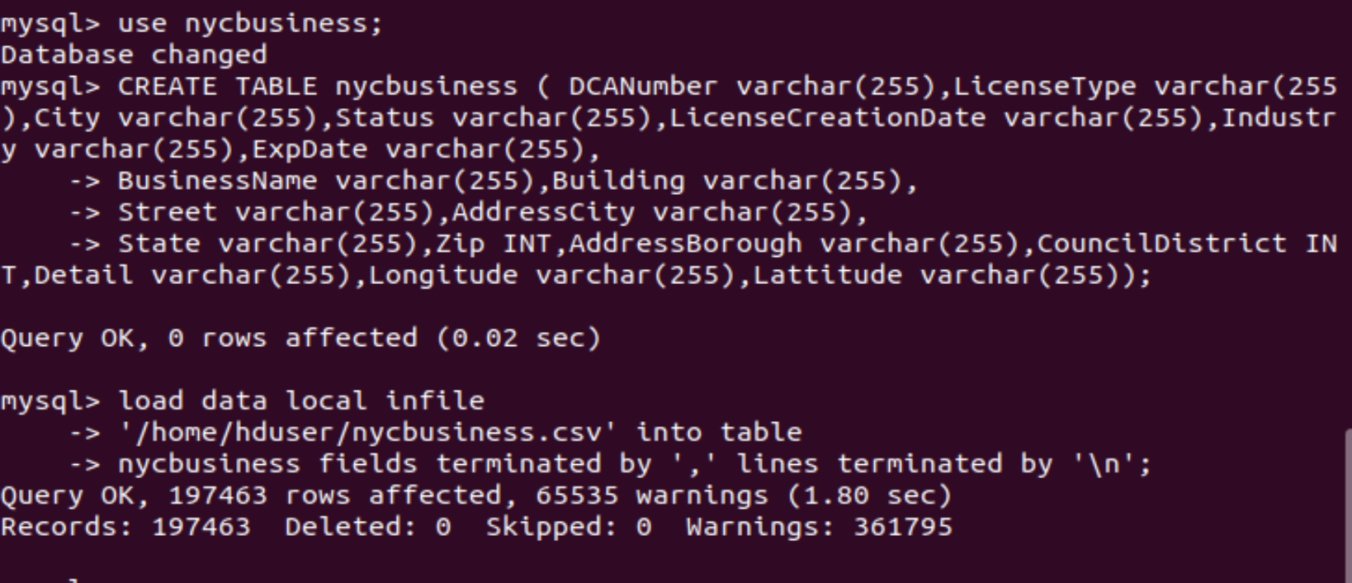

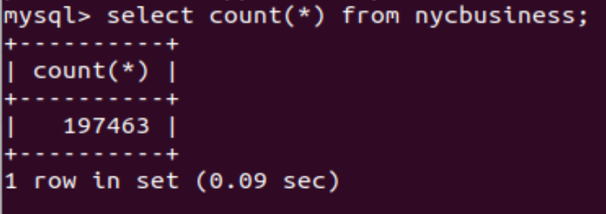

Data ingestion – Sqoop

sqoop import --connect jdbc:mysql://127.0.0.1/nycbusiness \

--username root \

--password mathi_08S \

--table nycbusiness \

--target-dir /nycbusiness -m1

Import successful.

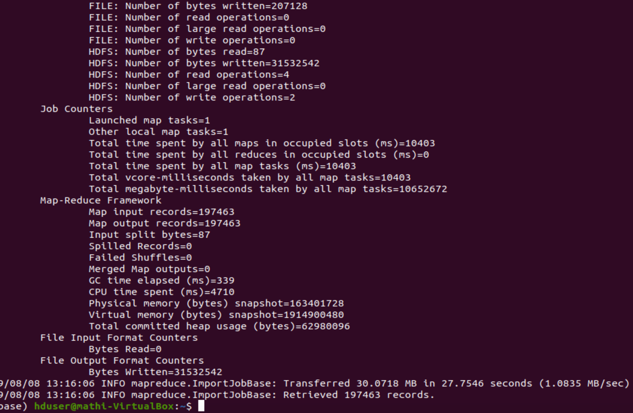

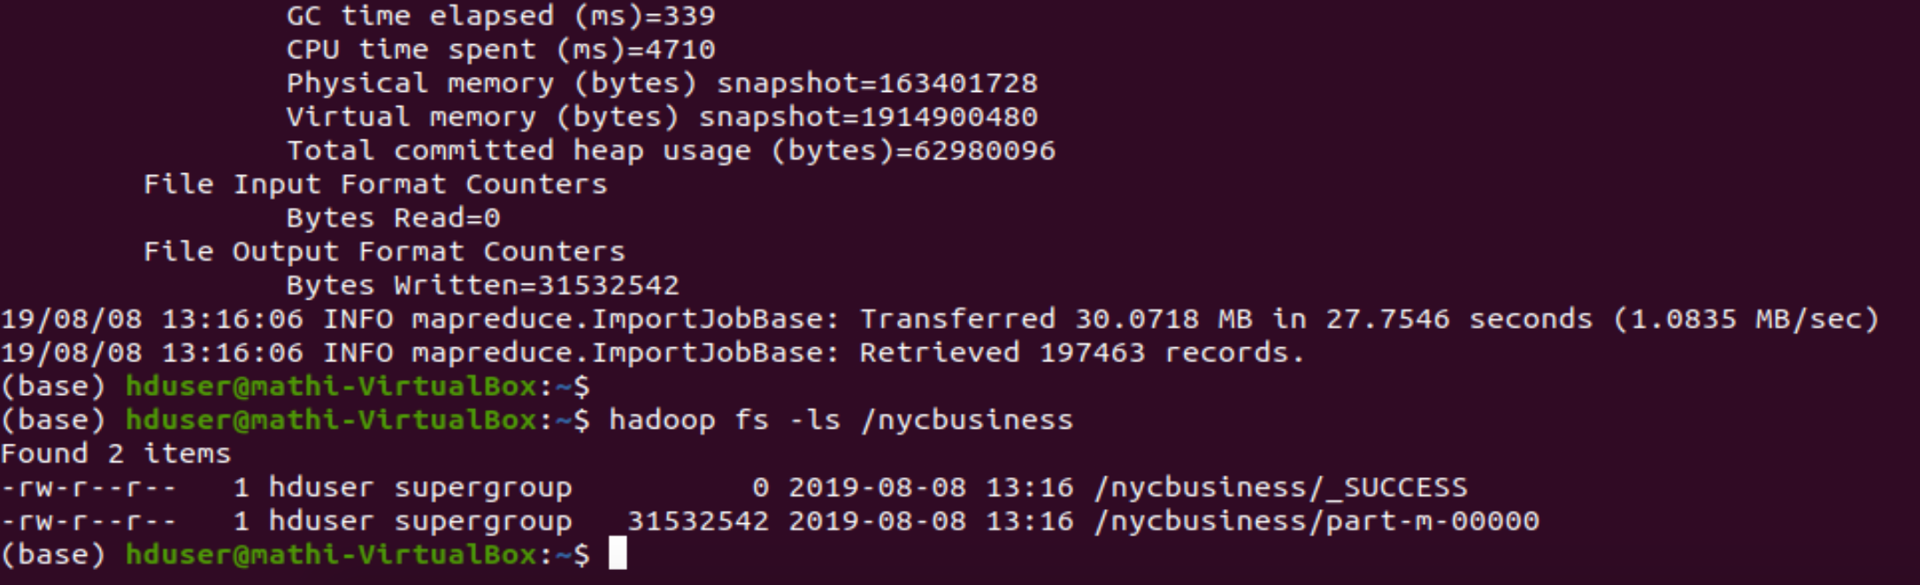

﻿hadoop dfs -cp /nycbusiness/part-m-00000 /nycbusiness/nycbusiness.csv

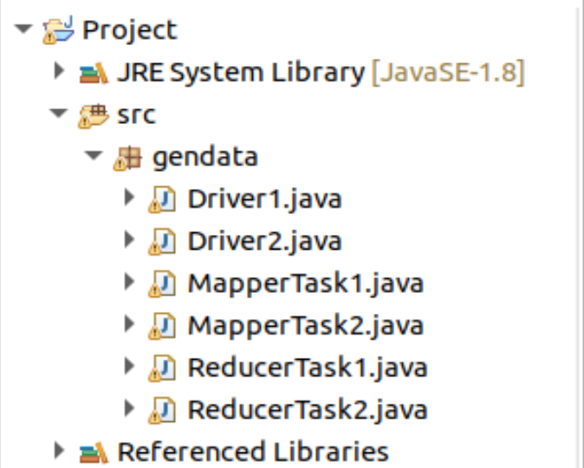

Using export function, 2 executable jar files are created and stored in hduser home folder.

1. Citynyc.jar
2. Industrynyc.jar



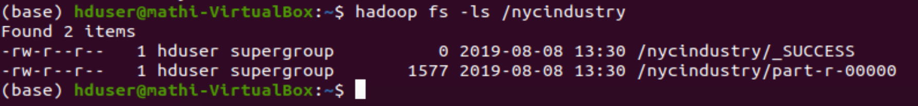

Copying to local file system.

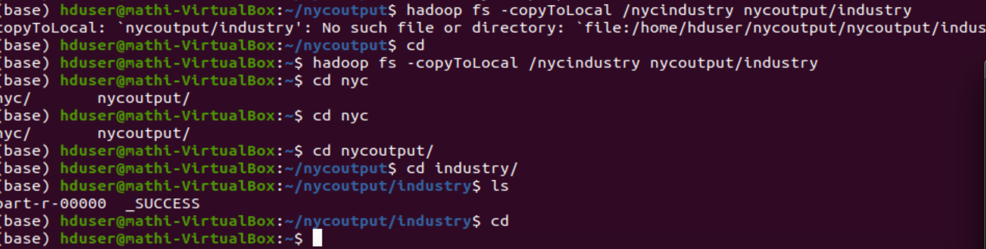

## Cityjar

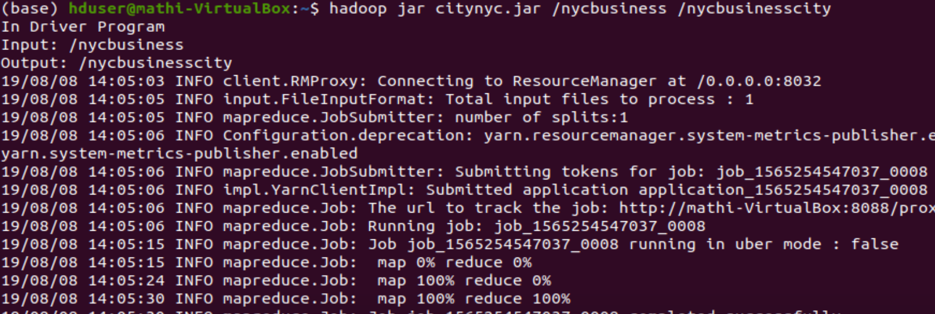

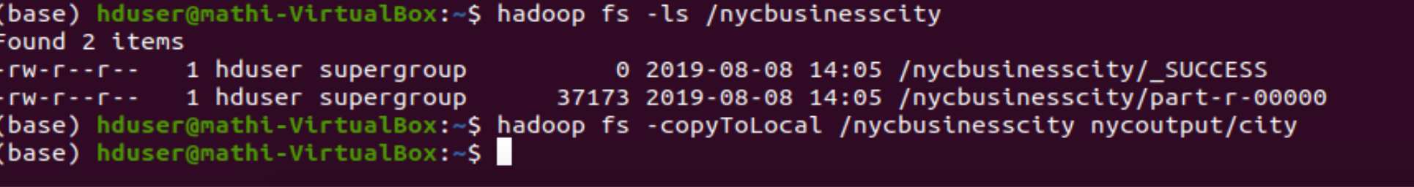

## HIVE:

CREATE TABLE nycbusiness ( DCANumber STRING,LicenseType STRING,City STRING,Status STRING,LicenseCreationDate STRING,Industry STRING,ExpDate STRING,

BusinessName STRING,Building STRING,

Street STRING,AddressCity STRING,

State STRING,Zip INT,AddressBorough STRING,CouncilDistrict INT,Detail STRING,Longitude STRING,Lattitude STRING)

ROW FORMAT DELIMITED

FIELDS TERMINATED BY ',';

LOAD DATA:

﻿load data inpath '/nycbusiness/nycbusiness.csv' into TABLE nycbusiness;

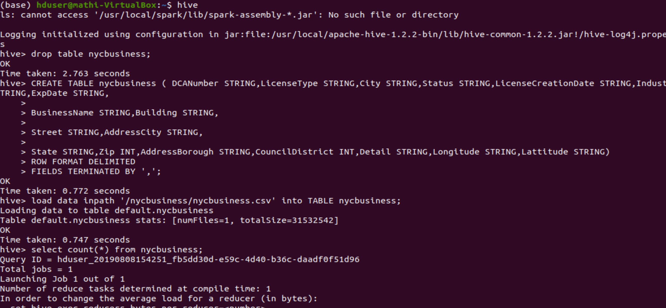

# Hive output 1: License type:

INSERT OVERWRITE DIRECTORY '/licensestate' ROW FORMAT DELIMITED FIELDS TERMINATED BY '\t' select licenseType,count(*) from nycbusiness group by licenseType;

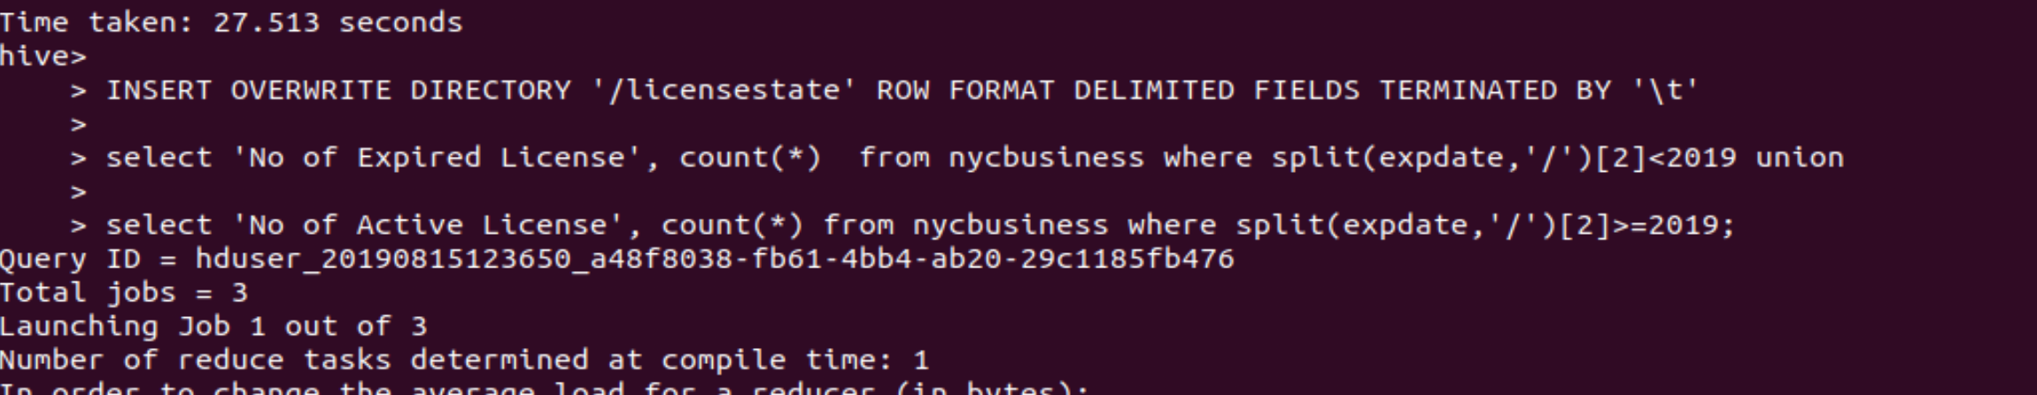

# Hive output 2:

INSERT OVERWRITE DIRECTORY '/zipcodewise' ROW FORMAT DELIMITED FIELDS TERMINATED BY '\t'

select zip,count(*) as noofbusiness from nycbusiness group by zip having noofbusiness>500;

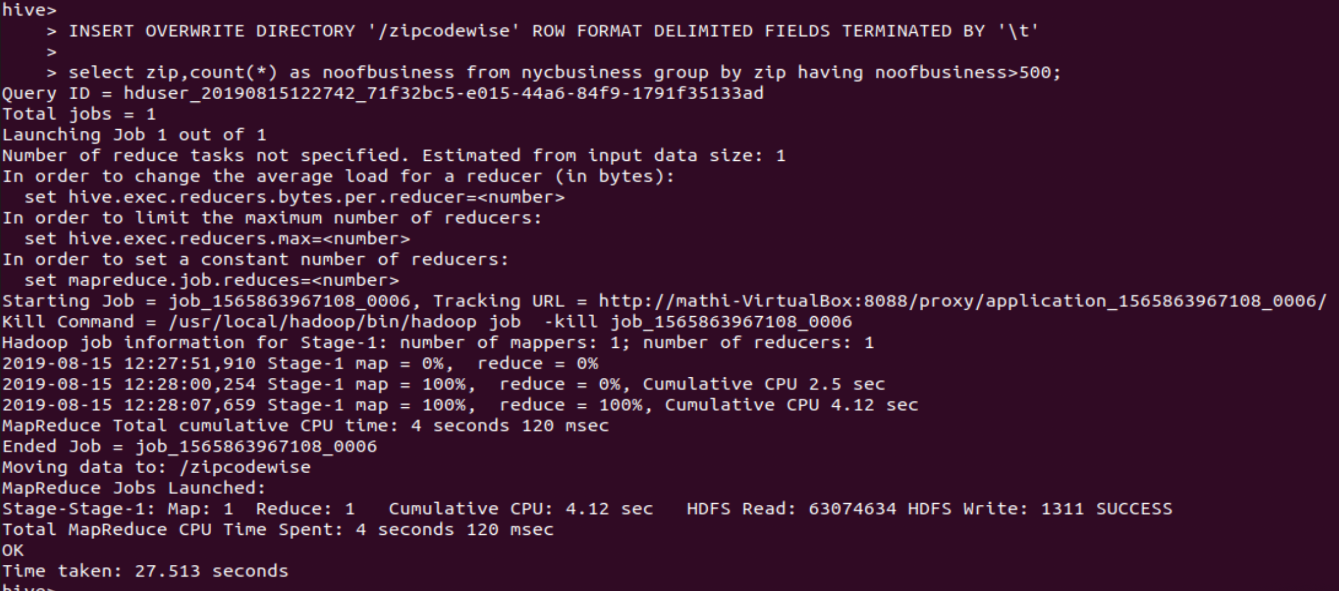



# Hive output3:

INSERT OVERWRITE DIRECTORY '/licensestate' ROW FORMAT DELIMITED FIELDS TERMINATED BY '\t'

select 'No of Expired License', count(*) from nycbusiness where split(expdate,'/')[2]<2019 union

select 'No of Active License', count(*) from nycbusiness where split(expdate,'/')[2]>=2019;

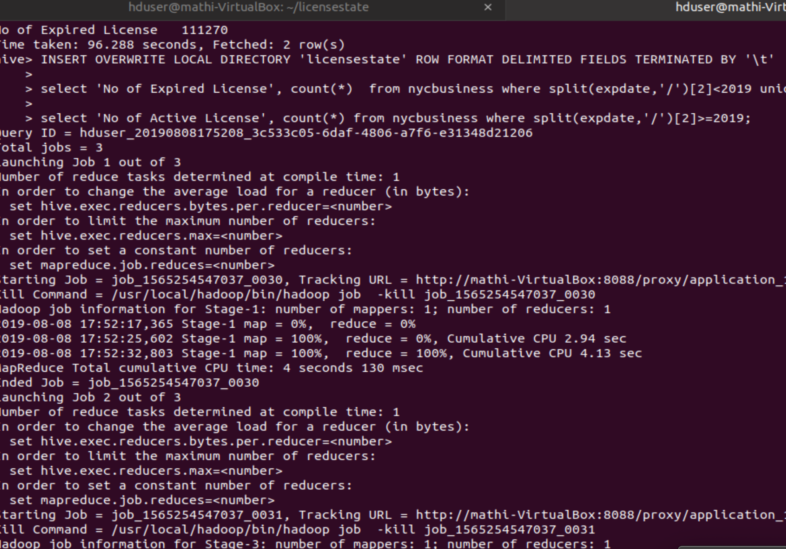

# Pig task

HBase table creation for MapReduce task.

MapReuce task - Industry in NYC.

Moving result of MapReduce task to HBase.

Created table ‘nycindustry’

Load data from HDFS location to HBase nycindustry table.

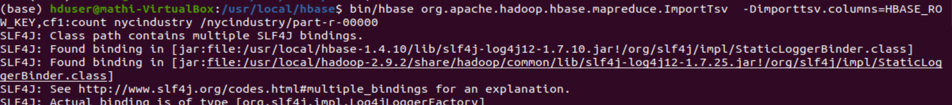

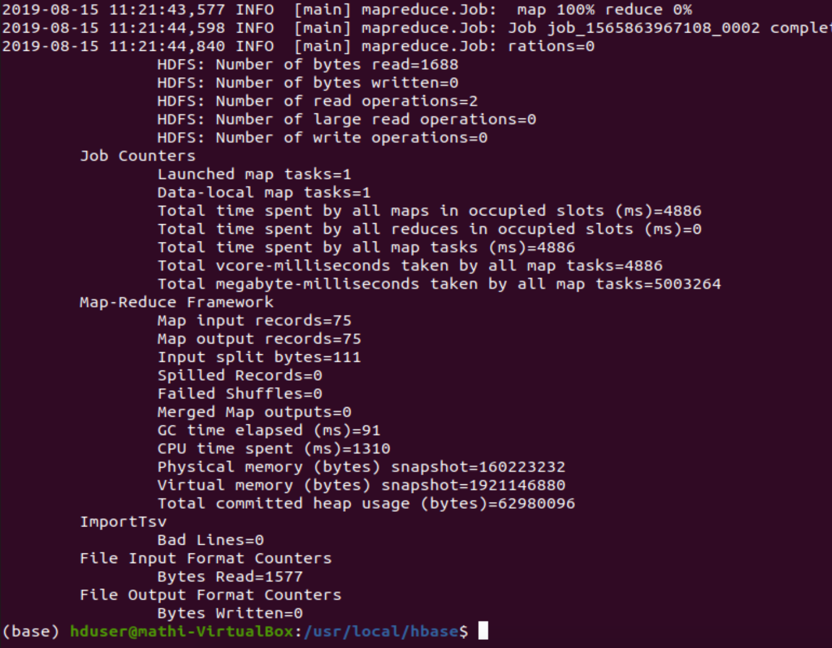

# Verify the data in HBase:

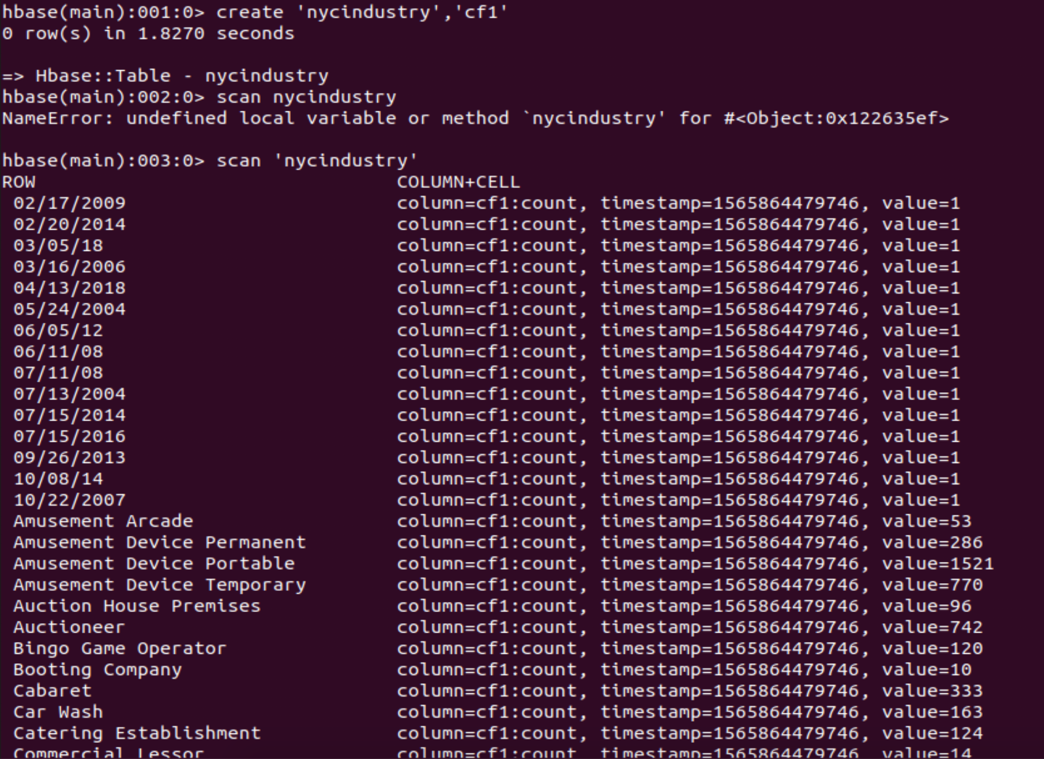

# MapReduce task2 output stored to HBase



## MapReduce Task2 City to Hbase

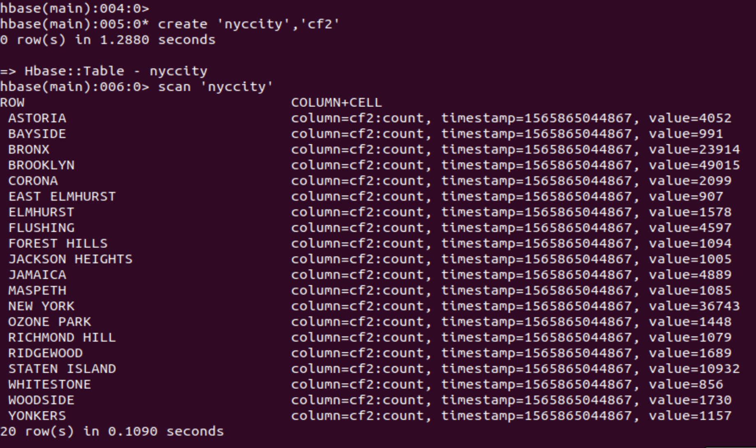

# Hive Output to HBase:



## HBase table.

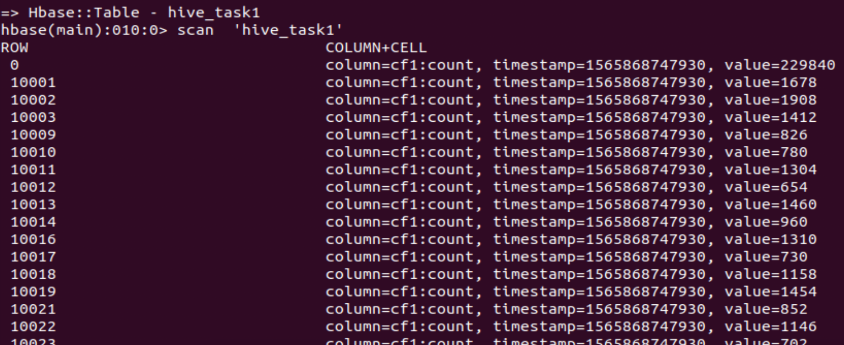

## Hive Task 2 .



## Hive Task 2 to HBase.

/licensestate/000000_0



## HDFS to Hbase

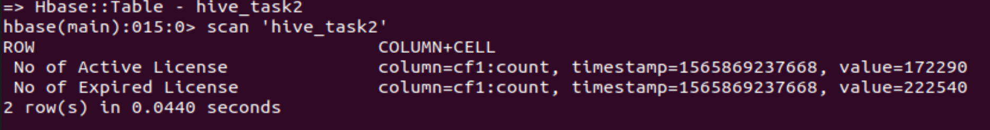

Moving data from HBase to Local files system

In hbaseout.sh command are stored to move the data from hbase to local directory.

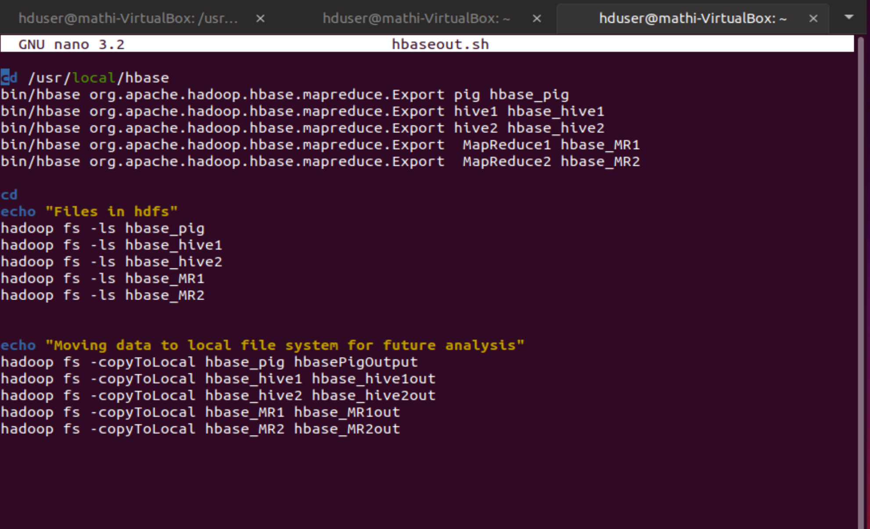

## Output of HBase to Local

